Step 1: Setup & Data Loading
Loading the necessary R libraries and importing the dataset into the environment.
- dplyr is used to prepare/clean data
- ggplot2 is used to visualize
- caret + e1071 are used to build models
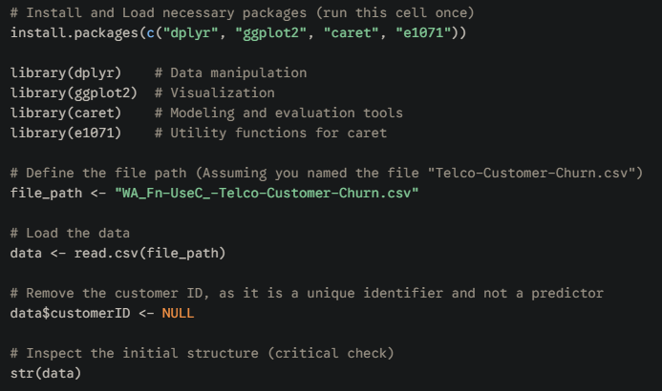
Step 2: Initial Data Cleaning & Transformation
Addressing the common issues in this dataset: missing values and the incorrect data type for TotalCharges. Logistic Regression will fail if the data contains NAs or non-numeric predictors.
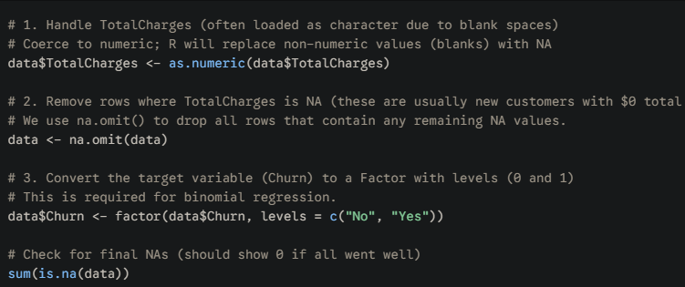
Step 3: One-Hot Encoding (Creating Dummy Variables)
Logistic Regression requires categorical variables (like "Fiber Optic" or "Month-to-Month") to be represented by binary numerical columns (0 or 1). We use the dummyVars function for this One-Hot Encoding. This to make the dataset fully numeric and ready for modeling.
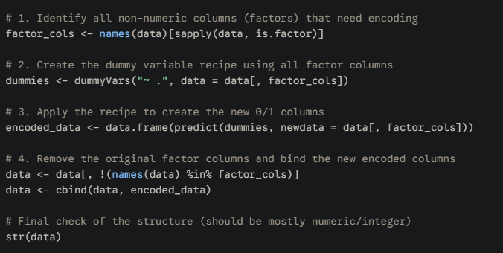

Got into some issue and I run this
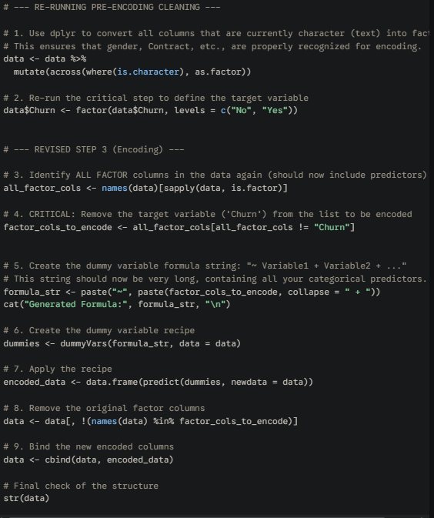

Step 4: Data Splitting (Setup for Prediction)
dividing the single, prepared data frame into two distinct sets to achieve a reliable measure of the model's predictive power (avoiding overfitting)
- Training Set (70%): Used to build the Logistic Regression model.
- Testing Set (30%): Used only at the end to evaluate the model's accuracy on data it has never seen.
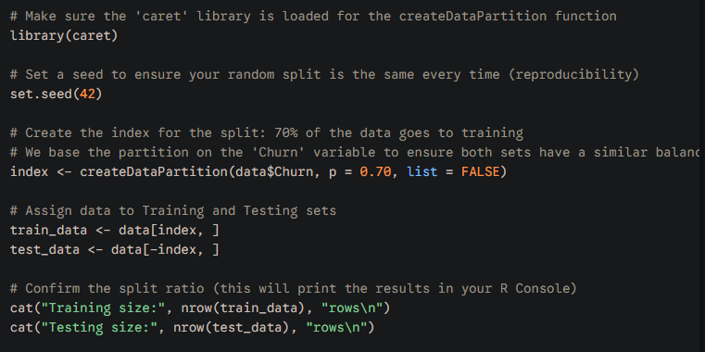
Step 5: Building the Logistic Regression Model
We're using the General Linear Model (glm) function in R to build the predictive engine. By specifying family = binomial(link = "logit"), we tell R to perform Logistic Regression, which is the standard technique for predicting a binary outcome (Yes/No, Churn/No Churn). The model will output coefficients ($\beta$) for every predictor variable. These coefficients determine the mathematical relationship between a customer's attribute (e.g., "Month-to-Month Contract") and their risk of churning.
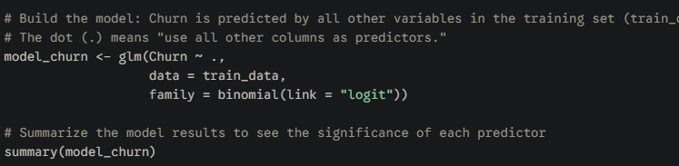

Step 6: Interpretation for Business (Odds Ratios)
The raw coefficients from the summary are in terms of log-odds—meaningless to business stakeholders. We must convert them to Odds Ratios (ORs).
An OR is the clear, actionable number: "A customer with feature X is Y times more likely to churn." This is the core insight the business needs for intervention.
A concise list of the top 5-7 risk factors that you will present in your final Tableau dashboard.
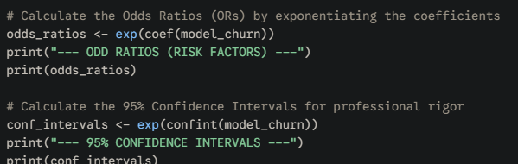
Step 7: Model Evaluation (Testing & Reliability)
The business needs to know how reliable your predictive model is. We have built it using the training data, but now we must test it on the completely unseen testing data to prove its real-world performance.
- Prediction: We will use the final model_churn to predict the churn status for every customer in the test_data.
- Evaluation: We will generate a Confusion Matrix to compare the model's predictions against the actual outcomes.
The final key metrics for your resume and report: Accuracy, Sensitivity (Recall), and Specificity. For a churn project, Sensitivity is the most important—it tells the company what percentage of actual churners your model correctly spots.
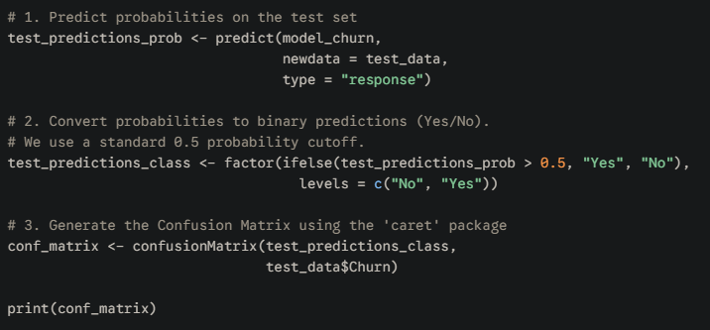
EXTRACTION
